**MEB 3063 ENGINEERING TEAM PROJECT**

**FINAL REPORT**

MAY 2020 SEMESTER

**“SMART DRUNK DETECTOR”**

By Group 23

|  |  |  |
| --- | --- | --- |
| **NAME** | **PROGRAMME** | **ID** |
| TAN LI TUNG | EE | 17002803 |
| NAZRUL AIMAN MAT AKHER | ME | 17005555 |
| NUR FATHIAH ZOLKIFLI | CE | 17004851 |
| DANIAL HARIEZ AHMAD NIZAM | ME | 17004263 |
| WONG XIAN WAN | CE | 16003946 |

**SUPERVISOR:**

DR. NOORAINI BT ZAINUDDIN

ASSOC. PROF. DR. HANITA BT DAUD

***ABSTRACT/ EXECUTIVE SUMMARY***

Drunk driving is one of the main contributors to road trauma in Malaysia. However, the current ways of detecting a drunk driver are not effective, which is through breathalyser or through observing abnormal driving conditions. However, in the advancement of the technology today, more sophisticated drunk driving mechanism should be used in order to increase the effectiveness and accuracy of drunk detection. The aim of this project, Smart Drunk Detector is to design a device that are capable of giving accurate drunk detection results. Smart Drunk Detector is build using a different approach which includes the use of Convolutional Neural Network (CNN) for image recognition and Non-Dispersive Infrared (NDIR) sensor. It functions by capturing an image of the driver and detect the alcohol concentration in the air around the driver seat simultaneously and the image recognition algorithm can give a prediction of whether the driver is drunk or sober. The accuracy of the device is 98.17% when tested using 600 test images. The device cost RM 235.65 only. Thus, the Smart Drunk Detector can be the future mechanism of drunk detection.

***TABLE OF CONTENT***

**1.0 INTRODUCTION 5**

1.1 BACKGROUND 5

1.2 PROBLEM STATEMENT 7

1.3 OBJECTIVES 7

**2.0 PROJECT MANAGEMENT 8**

2.1 TASK LISTING AND DISTRIBUTION 8

2.2 GANTT CHART 9

2.3 PROJECT WORKFLOW 10

**3.0 DESIGN THINKING 11**

3.1 LITERATURE REVIEW 11

3.2 DESIGN THINKING TOOLS 13

**4.0 METHODOLOGY 16**

4.1 WORKFLOW OF THE PRODUCT 16

4.2 DESCRIPTION OF THE WORKFLOW 17

**5.0 DESIGNING 18**

5.1 PROTOTYPE DESIGN 18

5.2 SCHEMATIC DIAGRAM 20

5.3 JUSTIFICATION OF FABRICATION CHOICES 21

**6.0 ENGINEERING ANALYSIS 21**

6.1 IDENTIFICATION OF TOOLS AND SOFTWARE 21

6.2 CHOSEN TOOLS AND SOFTWARE 24

6.3 JUSTIFICATION OF FABRICATION CHOICE 26

6.4 IMAGE RECOGNITION ALGORITHM 26

6.5 NDIR SENSOR 27

**7.0 ECONOMICAL/ BUSINESS CONSIDERATION 28**

7.1 CAPITAL COST CONSIDERATIONS 28

7.2 OPERATIONAL COST CONSIDERATIONS 28

7.3 ALTERNATIVE MATERIAL 29

**8.0 RESULTS AND DISCUSSION 30**

8.1 CONVOLUTIONAL NEURAL NETWORK (CNN) 30

8.2 NDIR SENSOR INTERPOLATION 32

8.3 SIMULATION INTERFACE 33

**9.0 RECOMMENDATIONS 37**

**10.0 CONCLUSION 38**

**11.0 APPENDICES 39**

11.1 IMAGE RECOGNITION CODE 39

11.2 NDIR INTERPOLATION CODE 42

**12.0 REFERENCES 43**

***1.0 INTRODUCTION***

In this section, the background of project, problem statement and objectives of the project will be discussed.

**1.1 BACKGROUND**

In the month of July 2020, there is an increased rate of road accidents due to drunk driving. This problem once again has become a hot issue in Malaysia. Research provided by the Economic and Social Commission for Asia and the Pacific (ESCAP) of the United Nations (2019), drunk driving contributed for around 25% of deaths on Malaysian roads as of 2018 [9]. Around 2,281 individuals were affected by drink driving accidents in Malaysia from 2011 to 2018, with about half of them dying and about half of them either suffering serious or minor injuries. This is not a small amount of numbers that can be neglected. Drunk drivers are basically a threat on the road that jeopardize innocent’s and their life.

**Figure 1: Number of Persons Who Were Injured or Died from Drunk Driving Accidents in Malaysia**

Under the former Road Transport Act 1987 drunk driving is subject to Section 45A (1) which provides for a fine of not less than RM1,000 and not more than RM6,000 or imprisonment not less than 12 months. For drunk driving that lead to death, offenders are subject under Section 44 of the Road Transport Act 1987, which carries a maximum fine of RM10,000 and a maximum jail term of 12 months. Yet actually, based on the general opinion, these penalties are seen as ineffective to deter drunk driving.

According to Jenis (2020), Datuk Shahul Hamid Abd Rahim a criminology claimed that Malaysia’s government should act on reforming nation’s laws to provide stricter punishment for drunk drivers [5]. This is due to the ignorance of drunk driver to current law. However, it is not a convenience way because developing a new law it needs to undergo eight steps which are recommendation, formulation, first reading in Dewan Rakyat, second reading in Dewan Rakyat, discussion, third reading in Dewan Rakyat, debate in Dewan Negara and submission to Yang di-Pertuan Agong to be gazetted (Tham, 2018) [7]. This process might take a long time, approximately one to two years. Thus, a new solution that are more convenience, time saving and feasible must be used to comply on the third Sustainable Development Goal (SDG) which are to ensure healthy lives and promote well-being for all at all ages.

Understanding the severity of the situation, we from Engineering Team Project Group 23 came together to develop an idea which are a device that attached in a car that can sense alcohol content of the driver. The device called as Smart Drunk Detection targets the sub goals of SDG 3: Ensure healthy lives and promote well-being for all at all ages, specifically target 3.6: By 2020, halve the number of global deaths and injuries from road traffic accidents [10].

**1.2 PROBLEM STATEMENT**

There are lot of people dies from the road accident due to drunk driver. This behaviour not just threaten the driver itself but the others innocent life on the road. Current law seems inadequate or ineffective but to reform a new law, it takes a long time and by the mean time there are high possibilities that the rate of road accidents due to drunk driving keep on increasing. Also, the current way of detecting drunk drivers using breathalyser is not effective enough to stop the drunk drivers on the road. Moreover, the accuracy of a breathalyser can be affected by a few factors, including error margin, partition ratios, radio frequency interference, improper calibration of device, left over alcohol in the drivers mouth and tainted breath samples (Attorney, J., 2020) [2]. A device with new drunk detection mechanism is needed in each of the vehicle. The device should eb able to be installed in all vehicles and the detection is more accurate and efficient.

**1.3 OBJECTIVES**

This project aims to achieve following objectives:

* Develop an easy-installed prototype named Smart Drunk Detector that can measure the alcohol concentration in the air inside the vehicle and stop drunk drivers from driving.
* Utilise the artificial intelligence (face recognition) technology in drunk detection mechanism.

***2.0 PROJECT MANAGEMENT***

**2.1 TASK LISTING AND DISTRIBUTION**

|  |
| --- |
| Tan Li Tung (17002803) |
| * **Project Director** * Organize and coordinate team meetings * Supervise project progress according to Gantt chart * Lead the designing of electrical circuits * Identify items and prices of electrical components * Compile and proofread reports * Compile the programming work |

|  |
| --- |
| Nur Fathiah Zolkifli (17004851) |
| * **Secretary** * Conduct literature review * Ensure each member submit the reflection form * Take attendance at each meeting and keep track of all deadlines * Prepare relevant documentation (e.g. minutes of meeting) * Conduct survey and questionnaire |

|  |
| --- |
| Nazrul Aiman Mat Akher (17005555) |
| * **Technical Director** * Conduct research on analogous inspiration * Handle the exterior design of project * Researching items and prices for construction of prototype * Advise on choice of materials * Conduct research on tools and software used in designing |

|  |
| --- |
| Danial Hariez (17004263) |
| * **Creative Director** * Conduct research on similar products on market * Handle the interior design of project * 3D drawings with AutoCAD * Select and compare alternatives in materials * Conduct research on related articles to support fabrication process |

|  |
| --- |
| Wong Xian Wan (16003946) |
| * **Simulation Director** * Prepare Gantt chart * Conduct background research on problem statement and objectives * Conduct research regarding the current solution * Create methodology and workflow of the project * Conduct simulation for the project * Evaluate the functionality of the project |

**2.2 GANTT CHAT (ACTIVITIES AND MILESTONE)**

|  |  |  |  |  |  |  |  |  |  |  |  |  |
| --- | --- | --- | --- | --- | --- | --- | --- | --- | --- | --- | --- | --- |
| Task Details | 1/6 | 8/6 | 15/6 | 22/6 | 29/6 | 6/7 | 13/7 | 20/7 | 27/7 | 3/8 | 10/8 | 17/8 |
| 7/6 | 14/6 | 21/6 | 28/6 | 5/7 | 12/7 | 19/7 | 26/7 | 2/8 | 9/8 | 16/8 | 23/8 |
| W1 | W2 | W3 | W4 | W5 | W6 | W7 | W8 | W9 | W10 | W11 | W12 |
| ETP briefing |  |  |  |  |  |  |  |  |  |  |  |  |
| First supervisor consultation |  |  |  |  |  |  |  |  |  |  |  |  |
| Design thinking workshop |  |  |  |  |  |  |  |  |  |  |  |  |
| Meeting with supervisor |  |  |  |  |  |  |  |  |  |  |  |  |
| Individual reflection |  |  |  |  |  |  |  |  |  |  |  |  |
| Brainstorming (SWOT analysis) |  |  |  |  |  |  |  |  |  |  |  |  |
| Finalization of Project Idea |  |  |  |  |  |  |  |  |  |  |  |  |
| In-depth Project Research |  |  |  |  |  |  |  |  |  |  |  |  |
| Marketability review & research |  |  |  |  |  |  |  |  |  |  |  |  |
| Problem statement and solution |  |  |  |  |  |  |  |  |  |  |  |  |
| 3D modelling |  |  |  |  |  |  |  |  |  |  |  |  |
| Schematic design |  |  |  |  |  |  |  |  |  |  |  |  |
| Simulation of Model |  |  |  |  |  |  |  |  |  |  |  |  |
| Extended proposal first draft |  |  |  |  |  |  |  |  |  |  |  |  |
| Proposal draft review |  |  |  |  |  |  |  |  |  |  |  |  |
| Extended proposal final submission |  |  |  |  |  |  |  |  |  |  |  |  |
| Development of design concept |  |  |  |  |  |  |  |  |  |  |  |  |
| Design concept draft |  |  |  |  |  |  |  |  |  |  |  |  |
| Simulate design concept |  |  |  |  |  |  |  |  |  |  |  |  |
| E-poster presentation preparation |  |  |  |  |  |  |  |  |  |  |  |  |
| Video presentation preparation |  |  |  |  |  |  |  |  |  |  |  |  |
| Demonstration of design concept |  |  |  |  |  |  |  |  |  |  |  |  |
| Group & individual video presentation |  |  |  |  |  |  |  |  |  |  |  |  |
| Evaluation of design concept |  |  |  |  |  |  |  |  |  |  |  |  |
| E-Poster evaluation |  |  |  |  |  |  |  |  |  |  |  |  |
| Final Report Preparation |  |  |  |  |  |  |  |  |  |  |  |  |
| Submission of Final Report |  |  |  |  |  |  |  |  |  |  |  |  |
| Submission of Peer Evaluation Form |  |  |  |  |  |  |  |  |  |  |  |  |
| Individual contribution |  |  |  |  |  |  |  |  |  |  |  |  |

**Table 1: Gantt Chart of Project**

**2.3 PROJECT WORKFLOW**

Brainstorming for the ideas of this project

**Flow Chart 1: Project Workflow**

Simulation succeeds

Simulation failed

Ideas is not feasible, not viable or not align with the theme

Ideas is feasible, viable and align with the theme

Video presentation and final report

Final checking on simulation

Demonstration to supervisor and panel

Testing the simulation

Build the model in simulation tool

Prepare the proposal

List 4 ideas and choose the best idea after discussion with supervisor

***3.0 Design Thinking***

**3.1 LITERATURE REVIEW**

According to Drunk Driving Penalties in Malaysia (2019), drunk driving is one of the contributors of road trauma in Malaysia [4]. Drunk driving is considered a very serious offence. If a person is caught driving in a drunk condition, the person may face penalties ranging from the suspension, disqualification or cancellation of their licence, fines, or imprisonment. In Malaysia, the legal blood alcohol concentration (BAC) limit for drivers is below 0.08. The BAC can be measured by using a breathalyser. It is an offence if a person refuses to take the breathalyser test (Drunk Driving Penalties in Malaysia, 2019) [4]. Drunk drivers also can be detected through observing abnormal driving behaviours.

The first way to identify a drunk driver is through the use of breathalyser. However, the accuracy of a breathalyser can be affected by a few factors, including error margin, partition ratios, radio frequency interference, improper calibration of device, left over alcohol in the drivers mouth and tainted breath samples (Attorney, J., 2020) [2]. The measurements will also be affected by the physiological factors of the drivers, such as gender, weight, breathing pattern and body temperature. This makes the use of breathalyser inaccurate.

Secondly, the way that a police officer identifies a drunk driver is by observing the strange behaviours of a vehicle. The strange behaviours include accelerating or slowing down quickly, almost hitting an object or other vehicle**,** drifting (moving in a straight-line at a slight angle to the roadway), driving in the centre or on the wrong side of the road, erratic braking, looking drunk (face close to windshield, drinking in the vehicle, etc.) and slowly reacting to traffic signals (Protect Yourself from Drunk Drivers: What You can Do., 2020) [6].

When a drunk driver is spotted by another driver, the other driver would not try to stop or interfere with the vehicle, break any laws to keep the vehicle in view, follow the vehicle too closely (it may stop suddenly) or try to detain the driver if the vehicle stops. This situation occurs because people do not want to risk their life to stop the drunk driving. The only thing that can the driver do is to call the police officers (Protect Yourself from Drunk Drivers: What You can Do., 2020) [6].

From the above evidences, it is clearly shown that we need a drunk detection system that can instantly detect drunk drivers and stop them from being on the road. The use of breathalyser will not be sufficient in reduce the drunk drivers on the road.

**3.2 DESIGN THINKING TOOLS**

**a) Analogous Inspiration**

According to “Analogous Research” (2018) [1], analogous inspiration is defined as *“a way to look for solutions in different contexts that may be applicable to your challenge or inspire an idea that is.”* With a source of inspiration, analogous inspiration is able to trigger ideas in sectors different to the original inspiration.

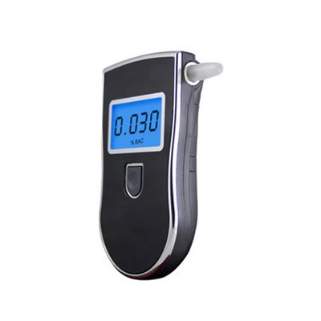Our team started with a brainstorming session. We have identified that the drunk driving is a very serious issue in Malaysia. We established a consensus that we want to focus on improving the current drunk detection system, which is by using a breathalyser by police. Our team started to figure out how to automate the breathalyser in a car by fixing the breathalyser inside the car. The driver would be required to use pass the breathalyser test before they can start the car engine.

**Figure 2: Breathalyser**

However, a drunk person might not know how to use a breathalyser due to the unconscious mind. This makes the use of breathalyser impractical. Our team utilise the analogous inspiration and we got a more advanced and suitable idea from the field of infrared and artificial intelligence (AI).

We have used the concept of analogous inspiration and we got the idea of utilising the use of AI to identify drunk driver. We also thought of using a nondispersive infrared (NDIR) sensor to detect the alcohol level of the air inside the car. This would further increase the accuracy of the detection system.

**b) Survey**

Our team members decided to publish a survey to gain more insights for your project and validate our problem statement. We have received a total of 92 responses from the survey. The results are as follows.

*1. Do you know what is drunk driving?*

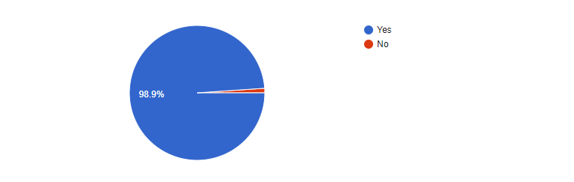

**Figure 3: Public Knowledge on Drunk Driving**

From the survey, 98.9% of the respondents know what drunk driving is. This helped us to validate our problem statement. The recent news displayed a lot of cases on drunk driving and this might be the reason for the public to know more about it.

*2. Have you encountered drunk drivers?*

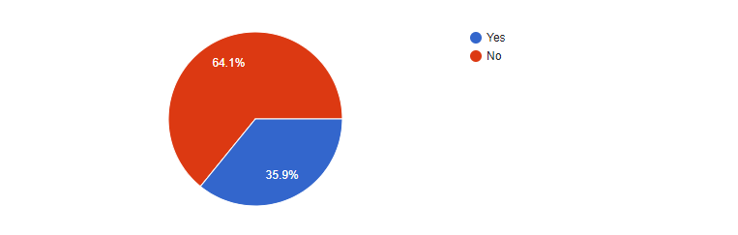

**Figure 4: Does the Public Encounter Drunk Drivers**

From these responses, we can see that 35.9% of the respondents personally encountered drunk drivers. This is a serious situation as drunk drivers can put the other drivers in danger. This is also an evidence that drunk driving needs to address.

*3. Do you think a smart drunk detection system can protect you from road accident?*

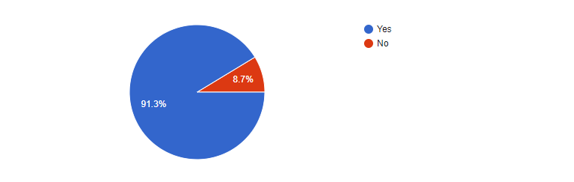

**Figure 5: Public Confidence on Smart Drunk Detection System**

From the survey, we can observe that 91.3% of the respondents are confident that Smart Drunk Detection system can protect them from road accident. This is a good sign for your team to develop the project as it will be helpful to the people especially drivers.

*4. What matters the most when it comes to a drunk detection system?*

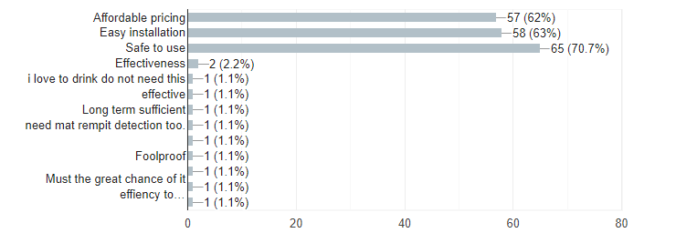

**Figure 6: Aspect That Matter the Most by The Public**

As expected, the public are most concern about the safety of the product. This is exactly the problem that we wanted to solve as the use of breathalyser is not effective enough at this point of time. The public also wish to have a device that can be easily installed and does not cost them a lot.

With this information, our team can build a drunk detection system that is affordable, reliable and safe to use. In short, we can conclude that our product will have a good market value as it can help to reduce the risk of drivers being expose to road accidents caused by drunk drivers.

***4.0 METHODOLOGY***

**4.1 WORKFLOW OF THE PRODUCT**

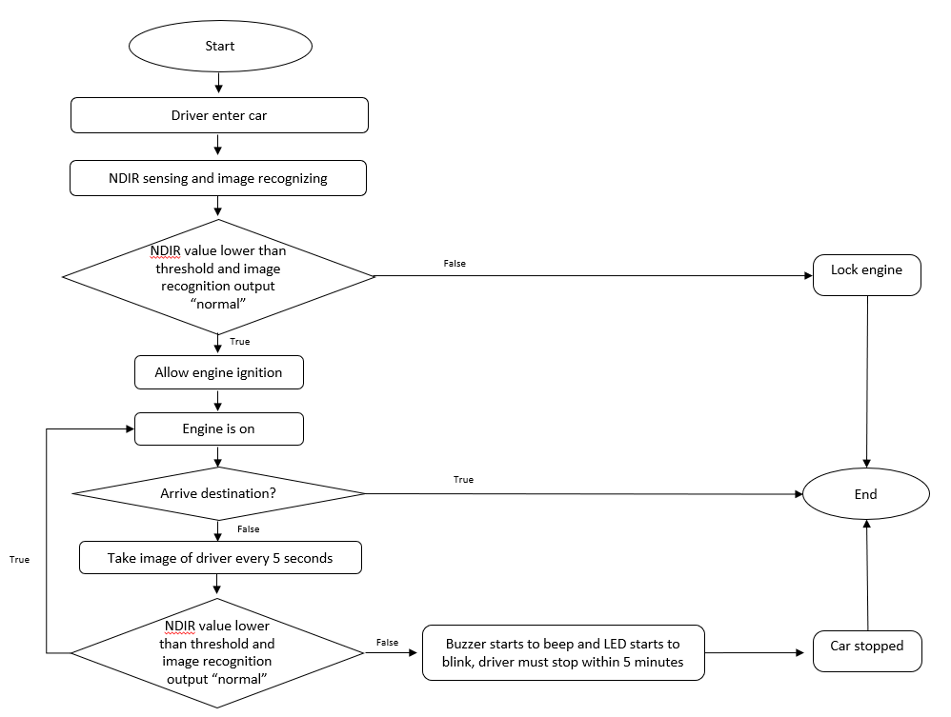

**Flow Chart 2: Workflow of Product**

**4.2 DESCRIPTION OF THE WORKFLOW**

As shown in the Flow Chart 2, the workflow of the project starts with a driver entering the car. NDIR sensor and camera will immediately capture the alcohol concentration in the air around the driver’s seat and the image of the driver for analysis. If the driver failed either test, the car ignition would not be allowed, and engine would be locked.

If the driver passed both of the tests, engine ignition is allowed. However, before the car is stopped, the NDIR sensor and camera will capture the alcohol concentration in the air around the driver’s seat and the image of the driver for analysis every 5 seconds. 5 seconds is chosen as the time range as the driver would not suddenly drunk in time within 5 second. The analysis is carried out once in 5 seconds as this would allow the system to detect any abnormalities earlier.

If the driver is somehow found to be drunk when the car is on the road, the LED will blink, and the buzzer will beep to alert the driver. The driver is given 5 minutes times to stop beside the road. 5 minutes is chosen as the driver will have time to stop. Even if the driver is stopping at the traffic light, the driver still can have time to stop beside road in 5 minutes.

Note: The device will not stop the car. To stop the car down when drunk driver is detected, the car needs to be modified. Therefore, in the earlier stage of the prototype, the device will only alert the driver that that the car needs to be stopped within 5 minutes to prevent any unwanted accident.

***5.0 DESIGNING***

**5.1 PROTOTYPE DESIGN**

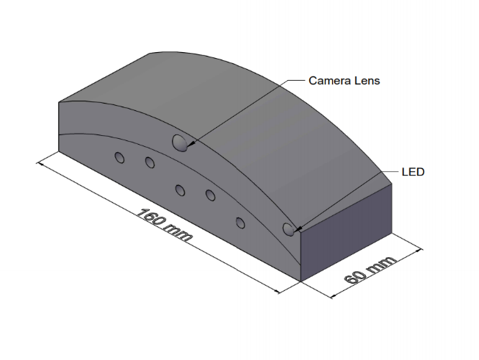

30mm

**Figure 7: Prototype Design View**

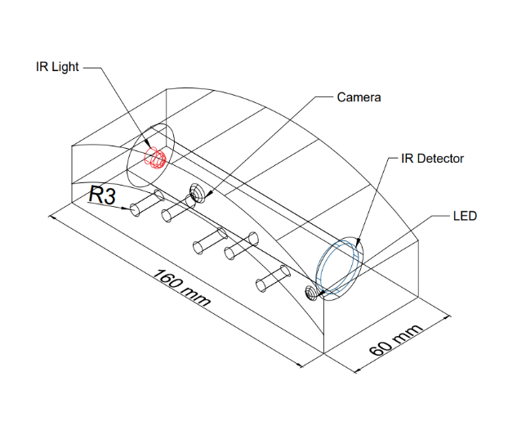

**Figure 8: Prototype Design X-Ray View**

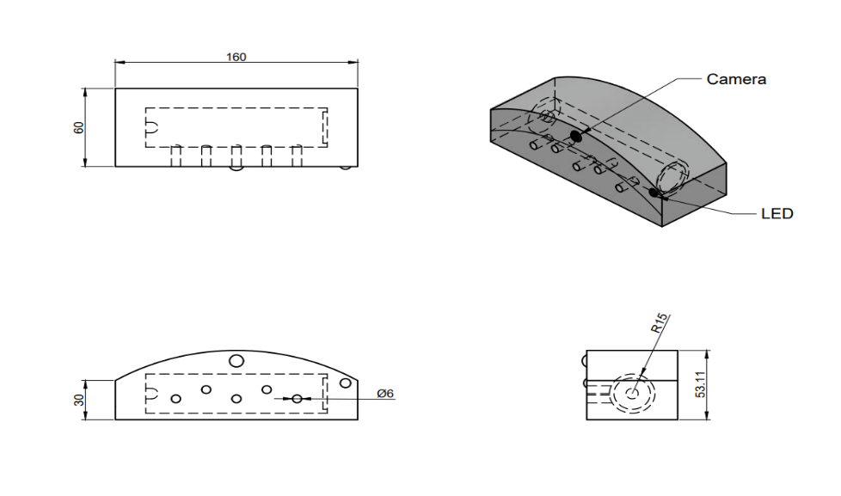

Side View

Front View

Side View

Top View

**Figure 9: Prototype Design**

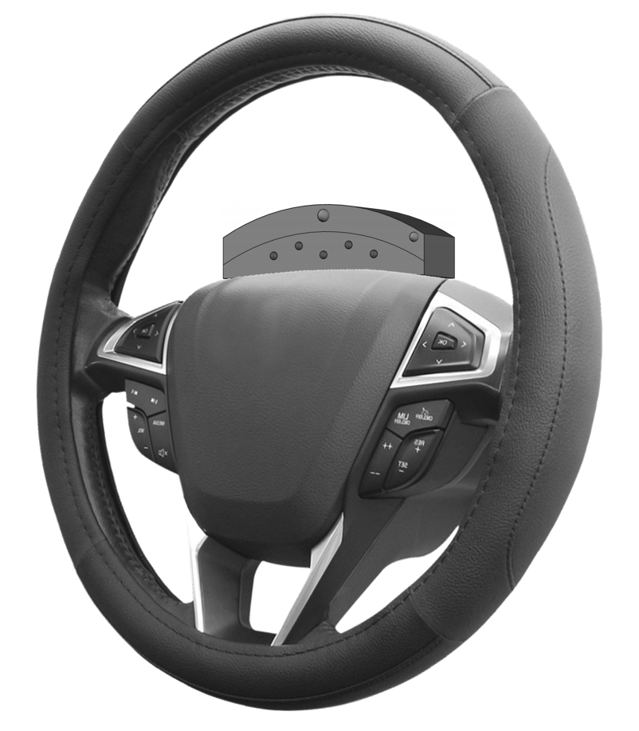

**Figure 10: Position of Smart Drunk Detector**

The prototype design is as shown in Figure 7, 8, and 9. The shape of this design is sleek shape to blend well with the steering wheel. There are a total of 5 inlet and outlet holes for the air particles to enter the NDIR sensor. There is a camera located at the top center of the prototype. The camera will capture image for image recognition purpose. This can further increase the accuracy of the device. There is also an LED located at the top right corner of the prototype. The LED will be lighted up to warn the driver if the NDIR sensor sense alcohol presence when the car is already driving on the road. The chamber for NDIR sensor is designed in cylindrical shape as most NDIR sensors in the market are tube shaped. Figure 10 also shows the position of the Smart Drunk Detector. It is placed at the center part of the steering wheel.

**5.2 SCHEMATIC DIAGRAM**

The schematic diagram of the prototype is shown in Figure 11. The schematic diagram consists of Raspberry Pi 3 Model B+, Non-Dispersive Infrared (NDIR) sensor, camera, LED and a buzzer. Raspberry Pi 3 Model B+ act as the microcontroller for the prototype where the algorithms of the device will be executed. The camera captures the image of the driver for image recognition while the NDIR sensor detects the alcohol concentration of the air in the car. The buzzer will beep, and the LED will blink to alert the driver when alcohol is detected or facial recognition system output “drunk” when the car is on the road.

**Figure 11: Schematic Diagram**

***6.0 ENGINEERING ANALYSIS***

**6.1 IDENTIFICATION OF SUITABLE COMPONENTS AND SOFTWARE**

Based on the workflow in Flow Chart 2, we need a few components in this project:

1. Microcontroller
2. Camera
3. NDIR Sensor
4. LED
5. Buzzer

**6.1.1 MICROCONTROLLER**

A microcontroller is the core component that will execute the algorithms. Two microcontrollers were chosen, analysed and researched, which are Raspberry PI 3 Model B+ and Arduino Uno. Both microcontrollers are open-source development board. The comparison of both controllers is shown in Table 2.

|  |  |  |  |  |
| --- | --- | --- | --- | --- |
| **Feature** | **RPi 3 Model B+** | **Arduino Uno** | **Suitability** | |
| **RPi 3 Model B+** | **Arduino Uno** |
| Output Pin | 40 | 20 | Yes | Yes |
| Camera Module Setup | Easy | Complicated | Yes | No |
| Memory | 1 GB | 32 kB | Yes | No |
| Programming Language | Python | C/C++ | Yes | No |
| Battery System | External | External | Yes | Yes |
| Software Capability | Flexible | Limited | Yes | No |

**Table 2: Comparison Between Microcontrollers**

Based on the criteria in Table 2, the chosen microcontroller to be used is the Raspberry Pi 3 Model B+. The main reason for the choice is that the Raspberry Pi 3 Model B+ is more compatible with Python, which the image recognition algorithm will be running on. The Raspberry Pi 3 Model B+ has larger memory so that the image recognition algorithm can run smoothly. On the other hand, if Arduino Uno is used, there are more risk of failure due to less resource for image recognition on Arduino. The complex setup of the camera can also cause error to the device. The image recognition algorithm may not be able to run on the smaller memory in Arduino Uno.

**6.1.2 CAMERA**

A camera is needed to capture the image of the driver for image recognition. Three cameras have been identified and analysed, which are Mini USB Camera, Webcam and Pi Camera. The Mini USB Camera is chosen in this project. The main reason of choosing the Mini USB Camera is that it is small in size, which is suitable to be fitted into the device. It is also cheaper as compared to the other cameras.

**6.1.3 NDIR SENSOR**

There are three model of NDIR sensor that were considered in the project, which are MH-Z14A, Banggod T6703 and MH-Z19. The selected model for NDIR sensor is the MH-Z14A. The reason of choosing it includes its compatibility with Raspberry Pi 3 Model B+. The MH-Z14A is also more widely used as compared to the other models. Therefore, more resources can be found for MH-Z14A. The MH-Z14A is also cheaper in price as compered to the other models.

**6.1.4 SUMMARY OF COMPARISON**

The summary of comparisons between components are shown in Table 3.

|  |  |  |  |
| --- | --- | --- | --- |
| **No** | **Item** | **Selection** | **Purpose** |
| **1** | **Microcontroller**  Arduino Uno Rev3-Main Board  Raspberry Pi 3 Model B+ Arduino Uno | Raspberry Pi 3 Model B+ | Our project work with machine learning algorithm that runs on Python. Raspberry Pi is more compatible with Python compared with Arduino Uno. |
| **2** |  USB 12.0 MP 6 LED Webcam Camera Web Cam With Built in For Laptop ...Raspberry Pi 8MP Camera Module V2  Mini USB Camera Webcam Pi Camera | Mini USB Camera | The camera needs to be small in size to fit into the device. Therefore, the Webcam cannot be used. Mini USB Camera is chosen in our project because it is cheaper as compared to Pi Camera. Pi Camera can be used when the allocated budget is higher. |
| **3** | **NDIR Sensor** MH-Z14A Banggood T6703 MH-Z19 | MH-Z14A | NDIR MH-Z14A is widely used as compared to the other models. This model is also cheaper as compared to the others. |

**Table 3: Summary of Components Choice**

**6.2 CHOSEN TOOLS AND SOFTWARE**

The chosen tools and software used in this project are listed as below with its purpose:

|  |  |  |
| --- | --- | --- |
| **No** | **Item** | **Purpose** |
| **1** | **Raspberry Pi 3 Model B+**   | Microcontroller of the device. Raspberry Pi 3 Model B+ is chosen as the machine learning algorithm is more compatible with it. The Raspberry Pi 3 Model B+ can execute the tasks faster as compared to the other model. |
| **2** | **Mini USB Camera**   | To take image of the driver. This camera is chosen as it is small in size and affordable. |
| **3** | **NDIR Sensor**   | To detect the alcohol concentration in the air in the car. This sensor is more accurate as compared to the gas sensor module. |
| **4** |  | Blink to indicate that the driver needs to stop the car within 5 minutes. |
| **5** |  | To alert the sleepy driver by creating beeping sound. |

**Table 4: Chosen Components**

The software used in this project are as below:

|  |  |  |
| --- | --- | --- |
| No | Software | Function |
| 1 | AutoCAD | To model the prototype in 3D |
| 2 | Online schematic tools | Design circuit schematics |

**Table 5: Software Used**

**6.3 JUSTIFICATION OF FABRICATION CHOICES**

For the prototype, plastic is chosen for the overall material. Plastics are derived from organic, natural materials such as coal, salt, natural gas, cellulose and also crude oil. As plastics are known to be good insulators, it is the most reasonable choice of material to be chosen for our prototype. As our prototype is built around a number of electrical components such as NDIR sensor and camera, material with good electrical insulator is best used to avoid current leakage throughout the whole prototype to prevent further problems such as current leakage and short circuit. Plastics are also widely produced making our prototype very cost effective considering the cheap price of plastics today. Aside from that, the material chosen has to be very light as our prototype needs to be attached to the steering wheel. An abundance of weight means that the steering wheel will be heavier causing discomfort to the driver. Plastic is a perfect material for this as it is very light (“The Properties of Plastic”, 2018) [8].

**6.4 IMAGE RECOGNITION ALGORITHM**

One of the core functions of the Smart Drunk Detector is the image recognition alogrithm. Two libraries on image analysis are identified and analysed, which are TensorFlow and PyTorch. Both of the libraries are capable of performing image recognition through the use of Convolutional Neural Network (CNN) model. The comparison between the two libraries are shown in Table 6. The comparison is based on the research by Welch (2020) [10].

|  |  |  |  |  |
| --- | --- | --- | --- | --- |
| **Feature** | **TensorFlow** | **PyTorch** | **Suitability** | |
| **TensorFlow** | **PyTorch** |
| Visualization | Native | Non-native | Yes | No |
| Deploy for Production | Available | Not Available | Yes | No |
| Graphing | Static | Dynamic | No | Yes |
| Learning Resource | More | Less | Yes | No |

**Table 6: Comparison Between Deep Learning Libraries**

Based on Table 6, the chosen library for this project is TensorFlow. The main reason of choosing TensorFlow as the core library is due to its capability to run in production. On the other hand, if PyTorch were used, the project might face difficulties in deploying the model.

**6.5 NDIR SENSOR**

The NDIR sensor is another important feature of the drunk detection mechanism. The NDIR sensor work by capturing the air surrounding the driver’ seat. The NDIR sensor then release infrared (IR) light of a specific wavelength to pass through the air and measure how much IR light is absorbed by the gas particles ("Why NDIR? | Senseair", 2020) [12]. Through this way, the concentration of alcohol in the air is measured. The process can be visualized in Figure 12.

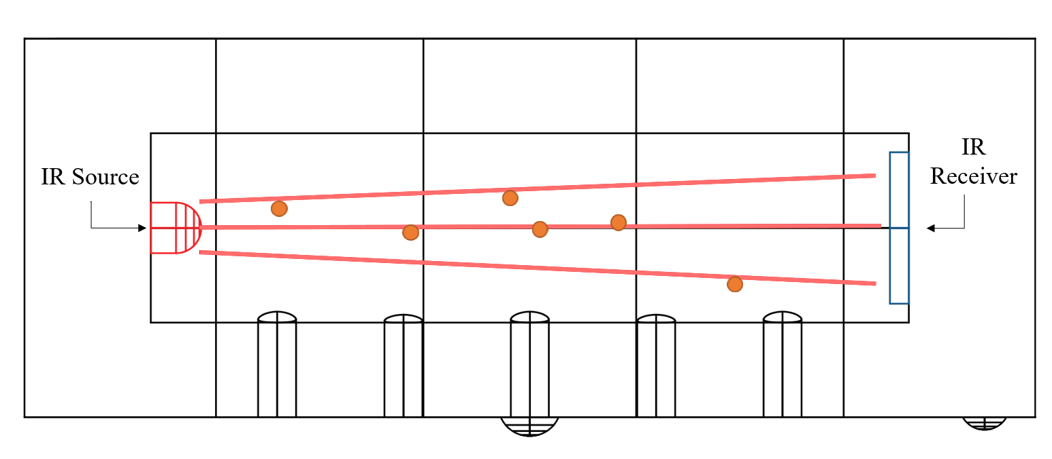

**Figure 12: Working of NDIR Sensor**

***7.0 ECONOMICAL/ BUSINESS CONSIDERATION***

**7.1 CAPITAL COST CONSIDERATION**

This capital cost needed for the project are as below. The cost listed is the estimated cost as the project is conducted fully online.

|  |  |  |  |
| --- | --- | --- | --- |
| **Item** | **Unit Price (RM)** | **Quantity** | **Subtotal (RM)** |
| Raspberry Pi 3 Model B+ | 120.00 | 1 | 120.00 |
| Buzzer | 1.00 | 1 | 1.00 |
| LED | 0.10 | 1 | 0.10 |
| Resistor | 0.05 | 1 | 0.05 |
| Jumper Wire | 2.50 | 1 | 2.50 |
| NDIR Sensor | 90.00 | 1 | 90.00 |
| Mini USB Camera | 12.00 | 1 | 12.00 |
| Plastics sheet | 10.00 | 1 | 10.00 |
| **Total (RM)** | | | **235.65** |

**Table 7: Economic Considerations of Project**

**7.2 OPERATIONAL COST CONSIDERATION**

Since the project is carried out online, there is no cost involved in the fabrication process. In UTP, students are able to fabricate the product at the Engineering, Prototyping and Innovation Center. Once the product is commercialised, the fabrication process would be carried out in a factory which can reduce the cost as the production are usually in bulk. The Smart Drunk Detection System is advisable to run using the power supply outlet in the car itself.

**7.3 ALTERNATIVE MATERIALS**

Plexiglass can be used to replace plastic as an alternative material. Plexiglass is a transparent petroleum-based material often manufactured in sheets as lightweight and shatter-resistant alternative to glass (“What is Plexiglass”, 2019) [11]. The most important characteristics of plexiglass is that it is an electrical insulator which can prevent current leakage in the system of the prototype. Plexiglass is an easy material to fabricate, bonds well with adhesive and solvents which means it will not cost much to create the prototype. The lightweight that this material offer is excellent for the prototype. It also has superior weathering properties compared to other types of plastics which means it will last a long time.

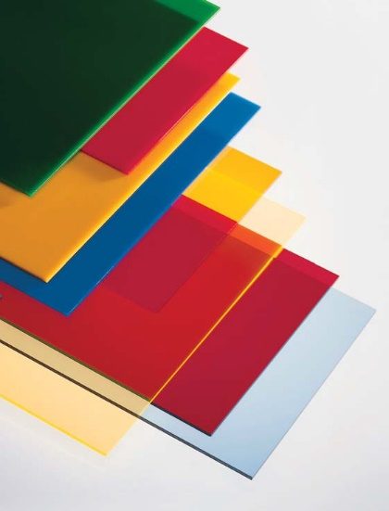

**Figure 13: Plexiglass**

As for the camera, it is possible to increase the accuracy of the drunk detection by having a camera with a better resolution. In the case of this project, a Pi Camera can be used as an alternative for the Mini USB Camera. Pi Camera is chosen as alternative as it has a higher resolution and it is compatible with Raspberry Pi.

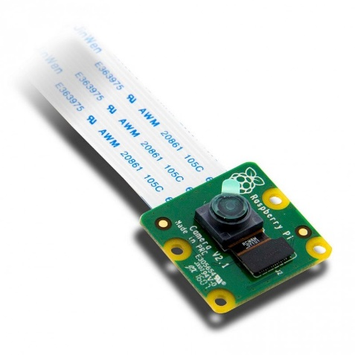

**Figure 13: Pi Camera**

***8.0 RESULTS AND DISCUSSION***

**8.1 CONVOLUTIONAL NEURAL NETWORK (CNN)**

The image recognition algorithm in this project is run on a CNN model which is built using the TensorFlow library by Google. The CNN model can be summarized as below:

Model: “sequential”

Layer (type) Output Shape Param #

conv2d (Conv2D) (None, 222, 222, 32) 896

max_pooling2d (MaxPooling2D) (None, 111, 111, 32) 0

conv2d_1 (Conv2D) (None, 109, 109, 64) 18496

max_pooling2d_1 (MaxPooling2 (None, 54, 54, 64) 0

conv2d_2 (Conv2D) (None, 52, 52, 64) 36928

flatten (Flatten) (None, 173056) 0

dense (Dense) (None, 64) 11075648

dense_1 (Dense) (None, 2) 130

Total params: 11,132,098

Trainable params: 11,132,098

Non-trainable params: 0

From the summary of the model, it is observed that the model has 8 layers, with 1 input layer, 6 hidden layers and 1 output layer. The total hyperparameters is 11132098 and all of them are trainable. The CNN model van also be visualized using the TensorBoard, which is shown in Figure 14.

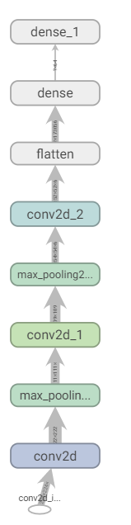

**Figure 14: CNN Model Used**

The model was built base on 1400 train images and 600 test images. The final accuracy of the model base on the 600 test images was 98.17%. The plot of accuracy vs epoch is shown in Figure 15.

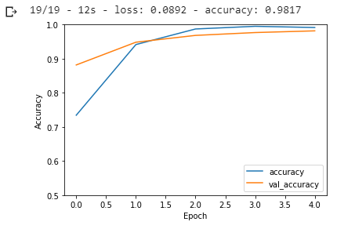

**Figure 15: Graph of Accuracy vs Epoch**

As the epoch (training iterations) increase, the accuracy of both training and validation increase. This shows that the model is not overfitted.

**8.2 NDIR SENSOR INTERPOLATION**

According to Budiman, Rivai and Pambayun (2016) [3], the blood alcohol concentration (BAC) is 0 for 0% NDIR value, 0.15 for 20% NDIR value and 0.26 for 60% NDIR value. Based on the reading listed above, interpolation is performed to get the relation of alcohol and NDIR reading. The method used in this section is Simple Linear Regression (SLR).

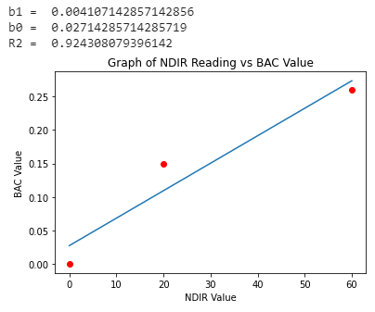

**Figure 16: Simple Linear Regression on NDIR Sensor Value**

From the result shown in Figure 16, the linear relationship between BAC and NDIR value is defined as:

In this section, there are only three data points are used. This is due to the project is done online. The accuracy of the reading can be further increased by collecting more data points from the actual NDIR sensor. However, this is the best data that the team can gather to be used in this project. From Figure 16, the R2 score is observed to be 92.43% which means that the data is nearly fit to the regression line.

**8.3 SIMULATION INTERFACE**

In order to simulate the working of the device, a web-based simulation interface is built. The simulation interface allows the user to upload an image and key in a NDIR reading. The simulation interface is shown in Figure 17.

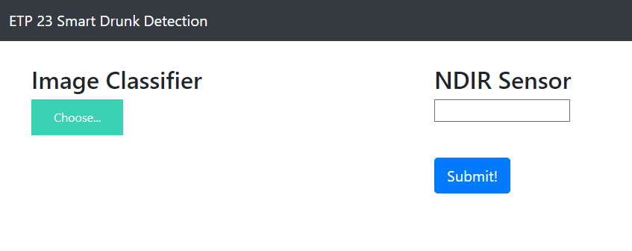

**Figure 17: Smart Drunk Detector Simulation Interface**

The simulation interface is built based on HTML, CSS and JavaScript. As sown in Figure 17, there are two inputs section, which are the image input and the NDIR sensor value input. There are four scenarios can be simulated by using the interface. The image classifier will predict whether a driver is drunk or sober and the NDIR sensor section will give the Blood Alcohol Concentration (BAC) value of the driver.

**8.3.1 SCENARIO 1**

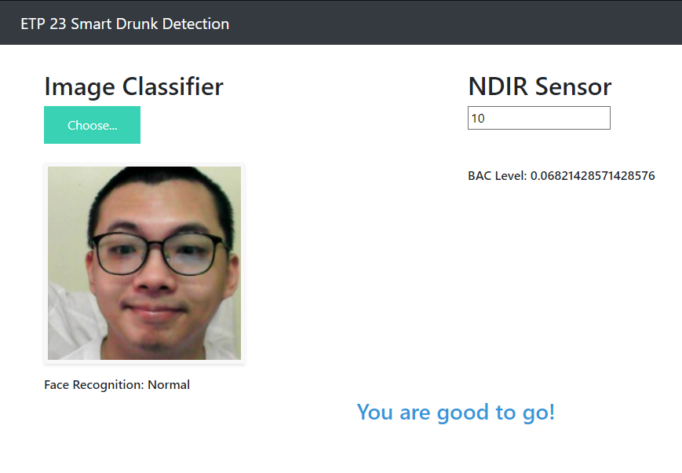

**Figure 18: Scenario 1**

Scenario 1 is when the image classifier output “Normal” and the BAC value is less than 0.08. The result is shown in Figure 18. The output of the simulation is “You are good to go!”. This indicates that the driver can drive safely.

**8.3.2 SCENARIO 2**

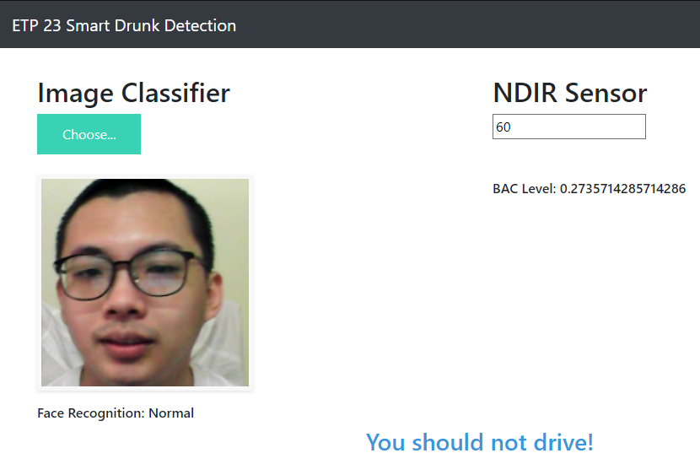

**Figure 19: Scenario 2**

Scenario 2 is when the image classifier output “Normal”, but the BAC value is greater than 0.08. The result is in Figure 19 shows “You should not drive!”. This is because even the driver looks normal, but the blood alcohol concentration is already greater than 0.08, which can cause driving impairment.

**8.3.3 SCENARIO 3**

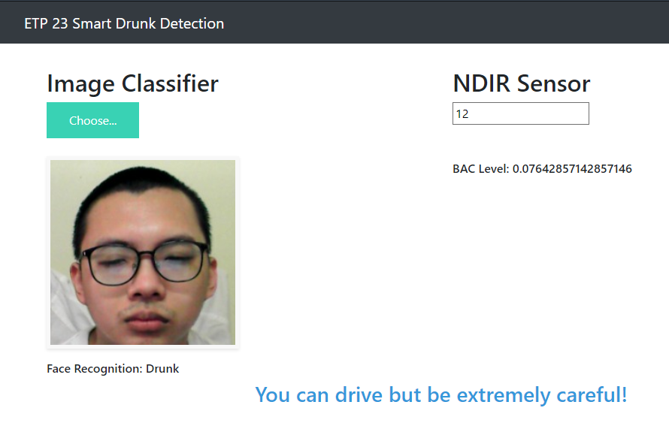

**Figure 20: Scenario 3**

Scenario 3 is when the image classifier output “Drunk”, but the BAC value is lower than 0.08. The result is in Figure 20 shows “You can drive but be extremely careful!”. The driver is allowed to drive with extreme careful because the BAC value of the driver is still less than 0.08. The driver in this condition does not have driving impairment. However, the driver still needs to be extremely careful to avoid any unwanted accident.

**8.3.4 SCENARIO 4**

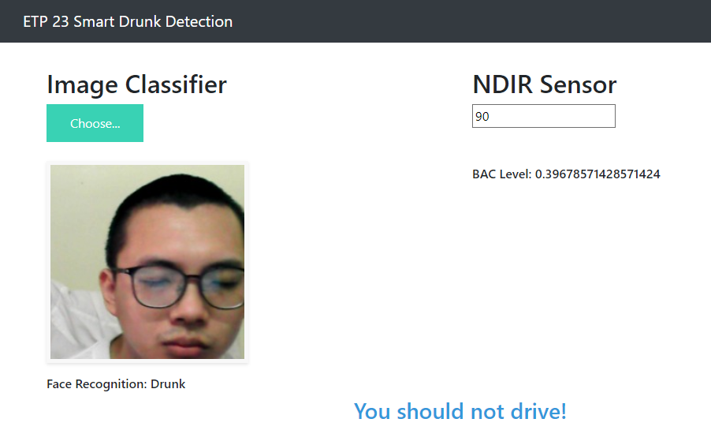

**Figure 21: Scenario 4**

Scenario 4 is when the image classifier output “Drunk” and the BAC value is greater than 0.08. The result is in Figure 19 shows “You should not drive!”. The driver in scenario 4 is confirmed to be drunk and having driving impairment. Therefore, the driver is prohibited from driving.

**8.3.4 SUMMARY OF SIMULATION INTERFACE**

The 4 scenarios are summarized in Table 8.

|  |  |  |  |
| --- | --- | --- | --- |
| **Image Classifier** | **BAC** | **Action** | **Justification** |
| Normal | < 0.08 | Good to drive. | Driver is not drunk. The driver can drive in a good condition. |
| Normal | ≥ 0.08 | Cannot drive | BAC of greater than 0.08 indicates that the driver is driving impaired. Thus, the driver is not allowed to drive. |
| Drunk | < 0.08 | Can drive but be extremely careful | The driver does not have driving impairment. But still need to be careful while driving to avoid unwanted accident. |
| Drunk | ≥ 0.08 | Cannot drive | Driver is confirmed drunk and driving impaired. Therefore, driving is prohibited. |

**Table 8: Summary of Simulation**

***9.0 RECOMMENDATIONS***

There recommendations for Smart Drunk Detector are listed in Table 9.

|  |  |
| --- | --- |
| **Criteria** | **Improvements** |
| Camera Resolution | * The image quality might be affected by the light intensity of the image captured. * To improve the image quality, a camera with better resolution can be used. * Infrared thermal camera can be used to increase the accuracy also. |
| Image Recognition Dataset | * The dataset used to build the CNN model is consider a small dataset. * To further improve the accuracy of the model, more dataset on different people can be used. |
| Design of Prototype | * The prototype can be design in a more flexible way so that it can fit in all models of vehicle. * The number of inlet and outlet holes can be increased to allow more air intake for NDIR measure. |
| Control Over Car | * The prototype designed in this project has no control over the car (cannot slow down or stop the car) * In real scenarios, the car can be stopped or slowed down when the driver is detected to be drunk. |
| Hazard Indicator | * In real world scenario, the hazard light of the car can be turned on automatically if the driver is detected to be drunk. * This can further alert the other drivers so that the road accident rate due to drunk driving could be decreased. |

**Table 9: Recommendation Table**

***10.0 CONCLUSION***

In conclusion, ETP Group 23 had successfully simulate a working Smart Drunk Detector. Smart Drunk Detector is a smart drunk detection device that works by using new mechanisms which are Non-Dispersive Infrared (NDIR) sensor and image recognition technology. The new drunk detection mechanism can improve the current drunk detection mechanism which is using breathalyser. The project is also proven to be feasible as the results are high in accuracy, which is shown by the high accuracy of image recognition, which is 98.17%. The device is also inexpensive, which only cost RM 235.65.

There are several criteria that could be improved to generate higher accuracy. Firstly, camera with better resolution can be so that the image recognition algorithm can perform well even when the light intensity is low. Besides, the dataset used for the model building can be increased so that the algorithm can perform image recognition with a higher accuracy. Furthermore, the design can be more flexible to fit in all types of car. The device also can have more control over the car to effectively stop the drunk drivers from driving.

By having the Smart Drunk Detector, the drunk detection mechanism is expected to be more accurate and effective. Thus, road accidents due to drunk driving is expected to be reduced.

***11.0 APPENDICES***

**11.1 IMAGE RECOGNITION CODE**

import tensorflow as tf

import datetime

from tensorflow.keras import datasets, layers, models

import matplotlib.pyplot as plt

import pandas as pd

import numpy as np

import cv2

import os

from tqdm import tqdm

import math

import matplotlib.image as mpimg

!rm -rf ETP-Dataset

!rm -rf Drunk-samples

!rm -rf Normal-samples

!git clone https://github.com/tanlitung/ETP-Dataset.git

!unzip /content/ETP-Dataset/Drunk-samples.zip

!unzip /content/ETP-Dataset/Normal-samples.zip

normal_path = "/content/Normal-samples/"

drunk_path = "/content/Drunk-samples/"

list1 = os.listdir(normal_path)

len_normal = len(list1)

list1 = os.listdir(drunk_path)

len_drunk = len(list1)

print("Number of normal dataset: ", len_normal)

print("Number of drunk dataset: ", len_drunk)

normal_filename = np.array([])

for i in range(len_normal):

normal_filename = np.append(normal_filename, normal_path + str(i) + ".jpg")

normal_df = pd.DataFrame({"filename": normal_filename})

normal_df['category'] = "normal"

drunk_filename = np.array([])

for i in range(len_drunk):

drunk_filename = np.append(drunk_filename, drunk_path + str(i) + ".jpg")

drunk_df = pd.DataFrame({"filename": drunk_filename})

drunk_df['category'] = "drunk"

df = pd.concat([normal_df, drunk_df], ignore_index = True)

df = df.sample(frac = 1).reset_index(drop = True)

plt.figure(figsize = (10,10))

for i in range(25):

plt.subplot(5, 5, i + 1)

plt.xticks([])

plt.yticks([])

plt.grid(False)

image = mpimg.imread(df.iloc[i].filename)

plt.imshow(image)

plt.xlabel(df.iloc[i].category)

plt.show()

list1 = []

list2 = []

for i in tqdm(range(len(df))):

img_array = cv2.imread(df.iloc[i].filename)

if (df.iloc[i].category == 'normal'):

img_category = 1

else:

img_category = 0

img_array = img_array / 255.0

list1.append(img_array)

list2.append(img_category)

images = np.array(list1)

labels = np.array(list2).reshape(len(df), 1)

print("Images shape: ", images.shape)

print("Labels shape: ", labels.shape)

train_len = math.floor(0.7 * len(df))

test_len = len(df) - train_len

print("Number of train data: ", train_len)

print("Number of test data: ", test_len)

train_images = images[0: train_len]

train_labels = labels[0: train_len]

test_images = images[train_len: ]

test_labels = labels[train_len: ]

model = models.Sequential()

model.add(layers.Conv2D(32, (3, 3), activation = 'relu', input_shape = (224, 224, 3)))

model.add(layers.MaxPooling2D((2, 2)))

model.add(layers.Conv2D(64, (3, 3), activation = 'relu'))

model.add(layers.MaxPooling2D((2, 2)))

model.add(layers.Conv2D(64, (3, 3), activation = 'relu'))

model.add(layers.Flatten())

model.add(layers.Dense(64, activation = 'relu'))

model.add(layers.Dense(2))

model.summary()

log_dir = "logs/fit/" + datetime.datetime.now().strftime("%Y%m%d-%H%M%S")

tensorboard_callback = tf.keras.callbacks.TensorBoard(log_dir=log_dir, histogram_freq=1)

model.compile(optimizer ='adam',

loss = tf.keras.losses.SparseCategoricalCrossentropy(from_logits = True),

metrics = ['accuracy'])

history = model.fit(train_images, train_labels, epochs = 5, validation_data = (test_images, test_labels), callbacks=[tensorboard_callback])

plt.plot(history.history['accuracy'], label='accuracy')

plt.plot(history.history['val_accuracy'], label = 'val_accuracy')

plt.xlabel('Epoch')

plt.ylabel('Accuracy')

plt.ylim([0.5, 1])

plt.legend(loc='lower right')

test_loss, test_acc = model.evaluate(test_images, test_labels, verbose=2)

print(test_acc)

pred = model.predict(test_images)

list3 = []

for i in pred:

list3.append(np.argmax(i))

predicted = np.array(list3)

print(predicted)

list4 = []

for i in range(test_len):

list4.append(test_labels[i][0])

actual = np.array(list4)

print(actual)

test_df = pd.DataFrame({"actual": actual, "predicted": predicted})

test_df

def predict_image(index):

index = int(index)

img = test_images[index]

plt.imshow(img)

plt.xlabel("Normal" if test_labels[index] == 1 else "Drunk")

plt.show()

print("Predicted class: ", "Normal" if np.argmax(model.predict(img.reshape(1, 224, 224, 3))[0]) == 1 else "Drunk")

print("Actual class: ", "Normal" if test_labels[index][0] == 1 else "Drunk")

predict_image(4)

model.save('ETP_CNN_model.h5')

from keras.models import load_model

loaded_model = tf.keras.models.load_model('ETP_CNN_model.h5')

loaded_model.summary()

def predict_image(index):

index = int(index)

img = test_images[index]

plt.imshow(img)

plt.xlabel("Normal" if test_labels[index] == 1 else "Drunk")

plt.show()

print("Predicted class: ", "Normal" if np.argmax(loaded_model.predict(img.reshape(1, 224, 224, 3))[0]) == 1 else "Drunk")

print("Actual class: ", "Normal" if test_labels[index][0] == 1 else "Drunk")

predict_image(8)

**11.2 NDIR INTERPOLATION CODE**

import numpy as np

from sklearn.linear_model import LinearRegression

from scipy.stats import t,f

ndir = np.array([0, 20, 60])

bac = np.array([0, 0.15, 0.26])

n = len(ndir)

model = LinearRegression()

model.fit(ndir.reshape(-1, 1), bac)

print("b1 = ", model.coef_[0])

print("b0 = ", model.intercept_)

y_pred = model.predict(ndir.reshape(-1, 1))

SST = np.sum((bac - np.mean(bac))**2)

SSE = np.sum((bac - y_pred)**2)

SSR = np.sum((y_pred - np.mean(bac))**2)

MSR = SSR

MSE = SSE / (len(ndir) - 2)

F = MSR / MSE

R2 = (SST - SSE) / SST

print("R2 = ", R2)

plt.figure(figsize = (6, 4))

plt.plot(ndir, bac, 'ro')

plt.plot(ndir.reshape(1, -1)[0], y_pred)

plt.xlabel("NDIR Value")

plt.ylabel("BAC Value")

plt.title("Graph of NDIR Reading vs BAC Value")

plt.show()

***12.0 REFERENCES***

[1] Analogous Research | Design Methods for Education Policy. (2019). Retrieved 23 June 2020, from https://designforedpolicy.org/analogous-research

[2] Attorney, J. (2020). How Accurate Are “Breathalyzers”?. Retrieved 6 July 2020, from https://www.lawyers.com/legal-info/criminal/dui-dwi/how-accurate-are-breathalyzers.html

[3] Budiman, F., Rivai, M., & Pambayun, J. (2016). Non-Dispersive Infrared (NDIR) sensor design and its application on alcohol detection. 2016 International Seminar On Intelligent Technology And Its Applications (ISITIA), 411-416. doi: 10.1109/isitia.2016.7828695

[4] Drunk Driving Penalties in Malaysia. (2019, August 22). Retrieved June 24, 2020, from https://andatech.com.my/drink-driving-penalties-in-malaysia/

[5] Jenis, A. (2020, May 28). Calls for stricter punishment against drunk drivers. Borneo Post Online. Retrieved from https://www.theborneopost.com/2020/05/28/calls-for-stricter-punishment-against-drunk-drivers/

[6] Protect Yourself from Drunk Drivers: What You can Do. (2020). Retrieved 7 July 2020, from https://www.alcoholproblemsandsolutions.org/protect-yourself-from-drunk-drivers/

[7] Tham, J, V. (2018, Apr 8). 8 Stages A Bill Goes Through Before Being Passed As Law In Malaysia. SAYS. Retrieved from https://says.com/my/news/stages-a-bill-goes-through-before-being-passed-as-law-in-malaysia

[8] The Properties of Plastic. (2018, March 19). Retrieved from https://www.osborneindustries.com/news/plastic-properties/

[9] United Nations, Economic and Social Commission for Asia and the Pacific (ESCAP) (2019). Strategies to Tackle the Issue of Impaired Driving for Road Safety in the Asia-Pacific Region: Implementation Framework. Retrieved 27 June 2020, from https://www.unescap.org

[10] Welch, S. (2020). Pytorch vs. TensorFlow: What You Need to Know | Udacity. Retrieved 20 August 2020, from https://blog.udacity.com/2020/05/pytorch-vs-tensorflow-what-you-need-to-know.html#:~:text=PyTorch%20has%20long%20been%20the,solutions%20and%20smaller-scale%20models.

[11] What Is Plexiglass and What Is It Made Of?. (2019, May 5). Retrieved 21 June 2020, from https://glassdoctor.com/blog/what-is-plexiglass-and-what-is-it-made-of

[12] Why NDIR? | Senseair. (2020). Retrieved 20 August 2020, from https://senseair.com/